By the early 2010s, most states in the U.S. adopted the Common Core State Standards—of which does not have a requirement for cursive curriculum—in order to ensure that all students are taught the same throughout all schools. Contradictory to the idea behind introducing Common Core, a national survey conducted by Really Good Stuff Inc. in 2013 found that only 59% of teachers include cursive in their curriculum. While it is not nationally mandated, cursive is being taught in some cases which creates inconsistencies across American education. When facing the question of whether to require cursive handwriting, there are far more pros than cons.

Day by day, our world becomes more digital, and less reliant on the handwritten word. Schools across the United States are loosely teaching cursive to its students and having them turn to their keyboards instead. Cursive handwriting has been considered outdated and tossed aside to make way for our computers.

From the Constitution to the Declaration of Independence, the United States has a deep history filled with primary documents that students are required to study. Cursive handwriting may not be the format for pieces of writing today; however, many of these documents are written in cursive by the way of quill and ink. Without knowledge of cursive handwriting, studying primary documents—or replicas of them—becomes nearly impossible for students. Supplemental cursive lessons would make reading these documents a breeze. 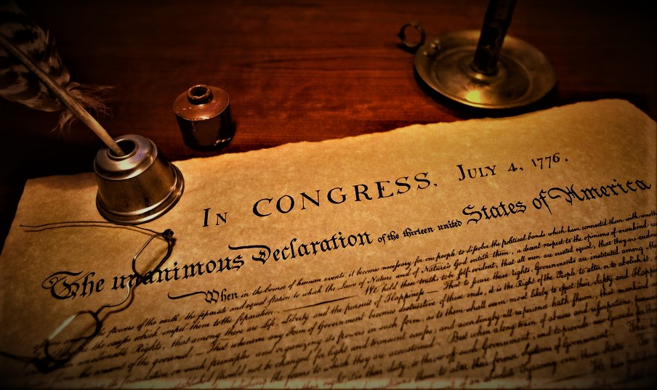

Cursive handwriting may benefit our brain health over time. Through EEG-analysis and brain scanning technology, handwriting in general has been clinically proven to stimulate the parietal lobe of the brain far more than keyboard typing. By introducing cursive handwriting at a fairly young age through school curriculum, it is feasible that American youth will have an increased ability with their fine motor skills as well as an increase in left brain activity.

Cursive curriculum may also better prepare students for notetaking in college. More and more classes are banning the use of computers due to their distracting nature, so students are forced to handwrite notes.

We have all had that professor who talks way too quickly. Scattered notes and on-the-fly shorthand tend to lead to forgotten information and disorganization. Cursive handwriting makes it easier and faster to take notes because it does not require the pencil to be lifted between each letter. A consistency in a student’s handwriting also poses the benefit of legibility and neatness which makes studying easier and efficient.

It is easy to forget that cursive is part of our everyday lives. Most credit card transactions are supposed to be validated by comparing the signatures on the back of the credit card to the signature on the front of the driver’s license. That is just one day-to-day example, but that example boils down to protecting identities. It is significantly harder for people to replicate a handwritten, cursive signature when it is practiced starting at a young age.

Cursive curriculum holds the power to benefit the livelihood of young people all over the country. Until it is implemented

on a national level, it is up to the youth to empower themselves.

**Sincerely,**

