**Vet Gala Social Media Strategy**

The social media campaign for the Vet Gala is easily promotable to younger audiences as they are tech savvy, so simplicity and accessibility for people that are in older age ranges is important for viewership and fundraising. More specifically, we want to target A-list celebrities to create as much buzz around our event as possible (Lady Gaga, Ariana Grande, Barack Obama etc.).

**Goals:**

* Surpass the amount raised in 2021 ($100,000)
* Encourage and receive donations via live events and sharing donation links frequently
* Catch the eye of pop culture media (MTV, VH1, TikTok) to blend trends with our event seamlessly to increase our impact on our social media audiences

**Generic Vet Gala Announcement (Release 10/17/2022)**

* **Caption:** "Annual Vet Gala to Take Place November 7th, 2022, at the Sommer Estate"
* A short, 30-second video where Annalise Sommers briefly details the Vet Gala event (where, when, why) will be uploaded to YouTube. Mentions that the Los Angeles General Hospital will be the only beneficiary of the funds raised. The link will be within the post on Facebook and Twitter, but in the account bios on TikTok and Instagram.

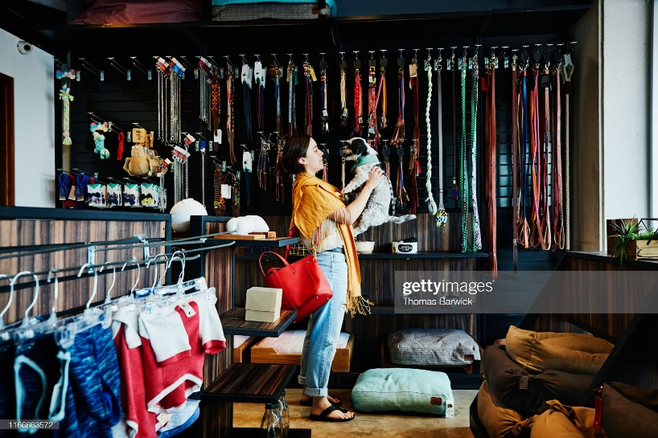

* The photo above is an example of a photo that should be included within the Instagram announcement post.

**Creator Collabs (10/21/2022)**

* Collaboration with online content creators/influencers is a great way to promote an event in an interesting way to audiences beyond that of the event host. A trendy way extravagant events like the Vet Gala include content creators/influencers is by having a camera crew follow them as they prepare for the event. In this instance, three popular influencers partake in filming a YouTube video where they shop for their outfits, as well as their pet’s outfits.
* **YouTube Video Title:** “Vet Gala Shopping with @/(insert creator handles) and pet(s) name(s)"
  + Follows the creators with their pets as they shop at lavish downtown L.A. stores. While they are shopping, the creators mention the importance of the Vet Gala to communal health. At the end of the video, the creators tease the final Vet Gala looks in order to encourage future viewership when the actual event rolls around.
  + There will be a link in bio ([www.lalalandmedia.com/vet-gala](http://www.lalalandmedia.com/vet-gala)) where people can find more information and donate.
* **Facebook and Twitter Title:** “Check out our new YouTube video where we follow @/(creators) and their four-legged friends as they find the perfect Vet Gala outfit! Be sure to visit [www.lalalandmedia.com/vet-gala](http://www.lalalandmedia.com/vet-gala) for more information on this event.”
  + Both posts will be accompanied by an embedded link to the YouTube video as well as an attached photo of the video thumbnail to draw viewers in.
* **Instagram Title:** “Come spend a day with @/(creators) to get the exclusive scoop on their Vet Gala outfits! Click the link in our bio for the YouTube video.”

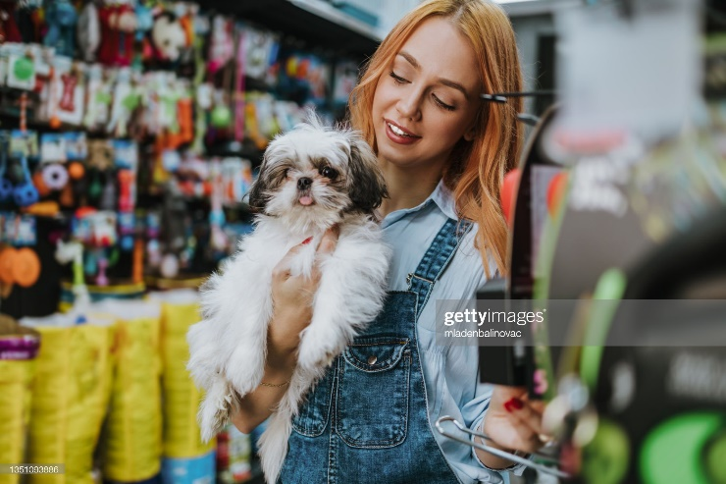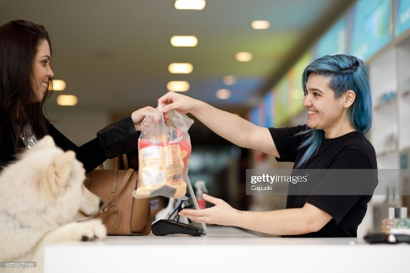

* The Instagram post should include candid photos of the creators/influencers shopping. The photos above are just examples.
* **TikTok Title(s):** "Vet Gala Shopping with @/(insert creator handles) and pet(s) name(s)"
  + Three separate TikToks will be posted highlighting the individuality of each creator during the filming of the YouTube video. Three TikToks will guarantee a larger audience reach due to the irregularity of the “For You Page” algorithm. There will be text at the end of the video encouraging viewers to check out the YouTube video for a more exclusive look.

**Los Angeles General Hospital Video (10/31/2022)**

* It is important to remind the target audience about the purpose of this event, and its importance to the Los Angeles community.
* **YouTube Video Title:** "Your City Needs You"
  + Utilizing a dramatic title to draw people in. This is not clickbait as it is true, but just stated in a more dramatic way.
  + The video will follow David Nome, Los Angeles General Hospital spokesperson, as he tours the hospital with his dog, George. He highlights his excitement for the event, but gives viewers a firsthand look at how the Vet Gala will directly benefit and better serve the Los Angeles community. A link to the Lalaland Media website will be in the video’s description.
* **TikTok Video Title:** "While the Vet Gala is a fun night with our four-legged friends, we want to stress the importance of how beneficial this event is to the overall health of the Los Angeles community! Click the link in our bio to see more."
  + This TikTok will be a condensed version of the YouTube video designed to entice TikTok viewers to travel to YouTube to hear more about the Vet Gala’s importance. A link in the TikTok profile’s bio will make it easier for people to do so.
* **Twitter Title:** "While the Vet Gala is a fun night with our four-legged friends, we want to stress the importance of how beneficial this event is to the overall health of the Los Angeles community!"
  + Tweets are a simple, yet effective way to spread information quickly. By embedding the YouTube video link within the bio there will be far more viewership.
* **Facebook/Instagram Title:** "While the Vet Gala is a fun night with our four-legged friends, we want to stress the importance of how beneficial this event is to the overall health of the Los Angeles community! Los Angeles General Hospital spokesperson David Nome took us on a tour of the hospital while talking all things Vet Gala."
  + These posts both serve the purpose of spreading the news about the video, which is an important goal during this campaign. An embedded link to the YouTube video will be within each post as well as a photo of the YouTube video thumbnail to entice viewers to click the video link.

**Multi-Platform Red-Carpet Livestream Event (11/07/2022)**

* With the growing popularity of TikTok, so has the popularity of livestreaming. It is cheaper to operate because there are no necessary contracts with television companies to follow, and it allows the event planner more creative freedom. It is increasingly more accessible for livestream audiences to donate to the host across multiple platforms. This will help to reach the event goal of over $100,000 raised.
* A livestream will be free to watch on **Facebook, YouTube, TikTok, and Instagram**. Twitter will be a place where people can find red-carpet updates with photos of the celebrities as they arrive with their pets.
* **Livestream Title:** "Vet Gala 2022 Red Carpet Event"
* The livestream will be hosted by Ryan Seacrest, and while interviews are taken place, a clickable link will be found in the livestream chats where they can donate.

**Fundraiser Announcement (11/08/2022)**

* It is important to inform the public about an event’s success, especially if a large part of the event was supported through donations.
* **Facebook/Twitter Title:** "You all really outdid yourselves this time around! We could not have had this amount of success without the support of our community and those who donated over the last few weeks. Thanks to all your efforts, we raised $123,000 for Los Angeles General Hospital. Who knew that our four-legged friends had so much influence?"
  + Included in these posts will be a bar graph that shows how each year, the Vet Gala has raised more money than the previous year. This is an easy way to validate the public’s involvement in the event by showing how their help is directly impacting the event’s success.
* **Instagram Title:** "You all really outdid yourselves this time around! We could not have had this amount of success without the support of our community and those who donated over the last few weeks. Thanks to all your efforts, we raised $123,000 for Los Angeles General Hospital. Who knew that our four-legged friends had so much influence? Thank you for everything."
  + The caption is the same as Facebook and Twitter but will include additional media such as red-carpet looks and exclusive photos from inside the venue.

