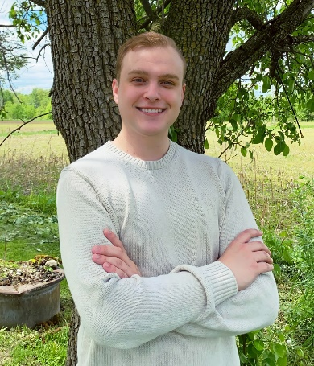Jacob Seiler is a student at Michigan State University and is expected to graduate with a Bachelor of Arts in journalism with a public relations minor by May 2023. During his first two years at MSU, Seiler worked at the Spartan Bookstore in the International Center. Seiler started as a general merchandise team member but was promoted to general merchandise team leader. As a key holder to a multi-million-dollar store, Seiler was responsible for taking inventory on all general merchandise, assigning duties to team members, opening/closing the store, and counting the store’s tills. In addition to his leadership responsibilities, he promoted new merchandise and current sales events across various Spartan Bookstore social media pages.

Seiler is currently working as a server and bartender at Applebee’s in Ionia, Michigan. He has been a team member for three years and is currently a neighborhood expert in both of his respective positions. As a neighborhood expert, Seiler is responsible for training newly hired employees, leading monthly meetings with fellow neighborhood experts, and assisting management throughout shifts. During his time at Applebee’s, he has been unanimously named Employee of the Month twice—in June 2021 and January 2022.

Seiler is an Ionia County Horse 4-H alumni with nearly 10 years of service. He learned how to manage and maintain horse health while remaining patient while riding and competing. Seiler took on leadership within his 4-H club as club treasurer for three years. Seiler volunteers at local 4-H events to give back to the community with his free time.