**There Is No Such Thing as the**

**Perfect Time**

How Michigan State University public relations alumna Zoe Kernohan’s perseverance and patience took her where she was meant to be.

By: Jacob Seiler

**A Bittersweet Ending**

After a few brutal final weeks leading up to her graduation in December 2021, Zoe Kernohan could not help but feel as if she missed closure to her time spent at Michigan State University.

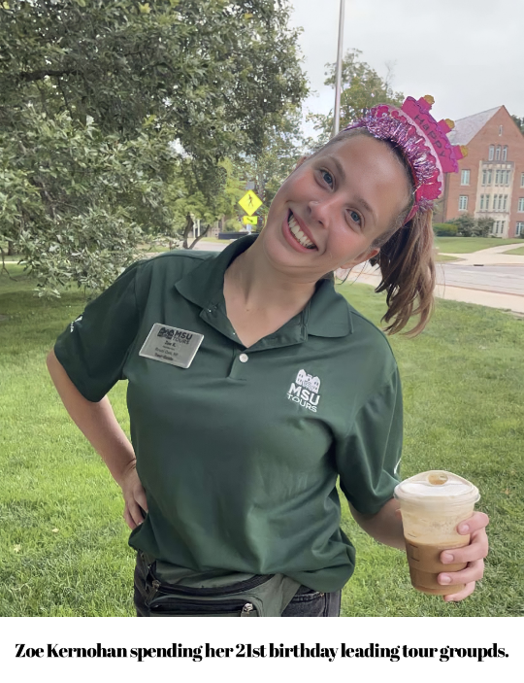Kernohan spent much of her time at MSU as a campus tour guide. With countless touring hours and educational fun facts about campus under her belt, Kernohan was looking forward to spending her last week as a tour guide fulfilling the tradition of wearing her cap and gown while leading a tour group. Unfortunately, just shy of two weeks prior to her graduation ceremony, Zoe Kernohan tested positive for COVID-19.

“I was honestly devastated,” said Kernohan, 21. “To have spent so much time touring campus over the years, and then to miss being able to relish in my hard work was disappointing to say the least.”

Luckily, Kernohan experienced only mild symptoms and has not noticed many side effects to date.

**Kernohan spent her 21st birthday leading tour groups around MSU's campus.**

“Of course, I am grateful to not have been extremely sick,” said Kernohan. “On the other hand, it stung a little bit having to be isolated from a happy time in my life when I was experiencing very few symptoms. It was a time of conflicting emotions and being in quarantine did not help those feelings subside at all.”

Kernohan tested negative for COVID-19 just two days before her graduation ceremony which allowed her to attend in person. She graduated from MSU with a Bachelor of Arts degree in media and information with minors in public relations, and women’s and gender studies.

“It was a bittersweet ending, for sure,” said Kernohan. “Celebrating my hard work and dedication toward getting my degree was fulfilling, but knowing that I was not able to have a normal end to my college career will always be in the back of my mind.”

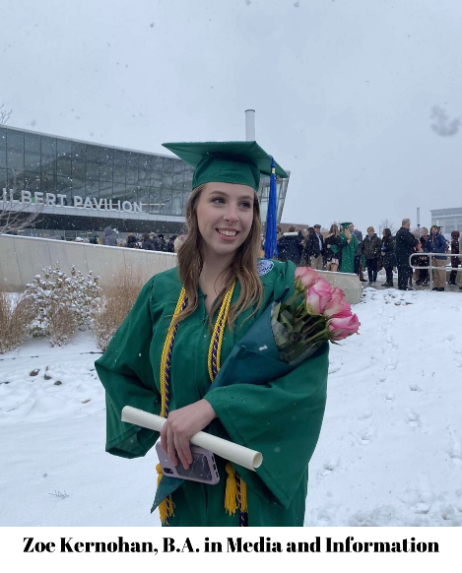

**Kernohan graduated with a bachelor's degree in media and information with minors in PR and women's and gender studies from Michigan State University in 2021.**

**A Fresh Beginning**

Knowing that she was pursuing her master’s degree in media and information, Kernohan says she was unsure of her next step professionally.

“I was not actively looking for a spring internship or even a new job,” said Kernohan. “Then out of nowhere, my friend told me that they needed an intern at the media company she works for. I applied and three days later I got the internship.”

Kernohan is currently working remotely out of East Lansing, Michigan for a media company located in Charlotte, North Carolina called Pillar4 Media. Kernohan can collaborate with other professionals in the media and information field while fulfilling her duties as a search engine optimization (SEO) intern.

“I never thought I would be doing search engine optimization, but here I am,” said Kernohan. “I do not work directly with the public relations team at Pillar4, but their team utilizes a lot of the knowledge that we are able to gather. The public relations team can better target and fulfill the needs of the public based off the information that we discover that our target audiences are looking up online.”

Pillar4 Media is a media company focused on mental and physical health. More specifically, their goal is to “connect people with the best brands in sleep, nutrition, fitness, and mental health.”

As part of her master’s degree program, Kernohan is currently working on her thesis. She is designing an app interface to help individuals struggling with eating disorders.

“This opportunity came unexpectedly, but the timing could not have been more perfect,” said Kernohan, 21. “I not only align well with the core values that Pillar4 operates by, but the research and work that I am doing goes hand and hand with where I am academically. It is cliché to say, but opportunities like this come from networking and making connections with people within the media and public relations space.”